Created Jenkins machine and installed JAVA, GIT MAVEN TOMCAT and Jenkins
Created 3 webhook jobs
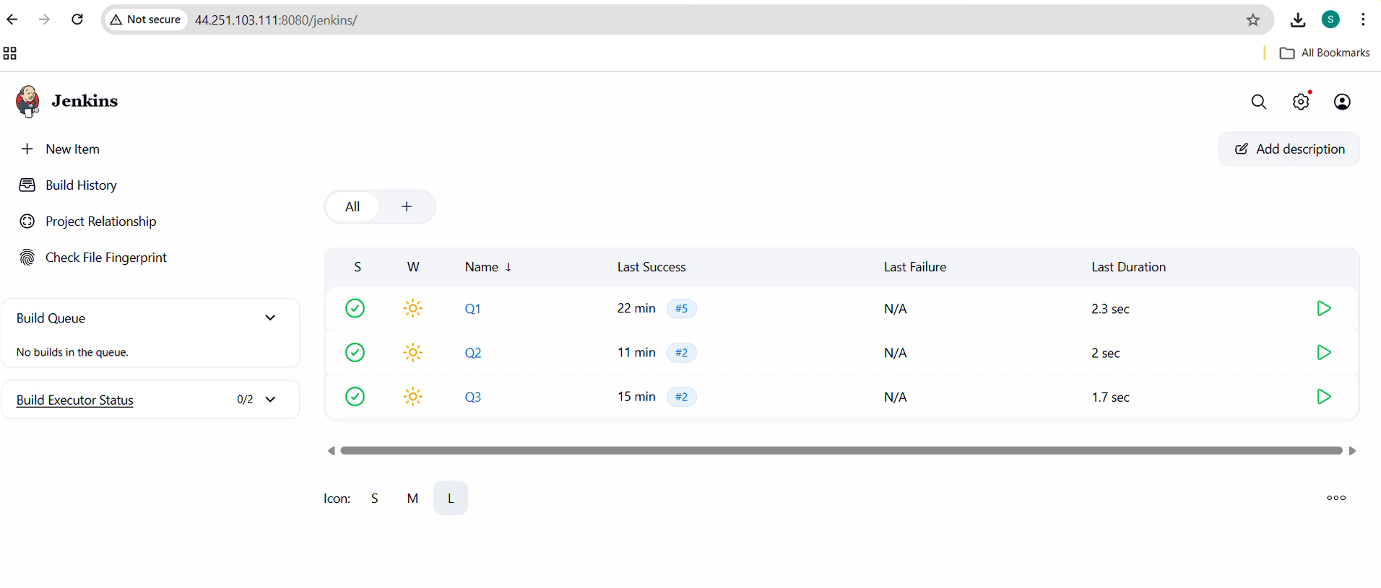
Job 1 auto build by webhook when changes made in repo 1 2026-Q1 branch
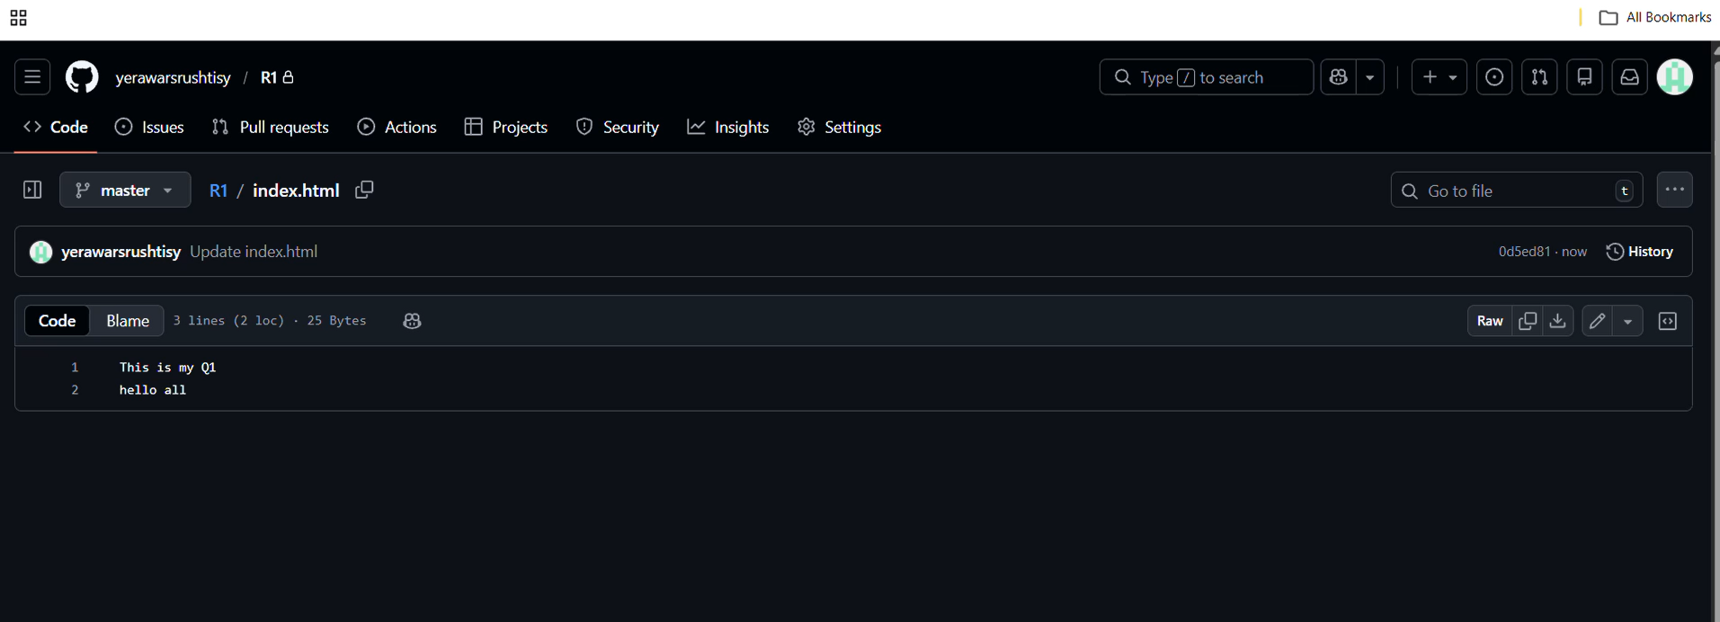

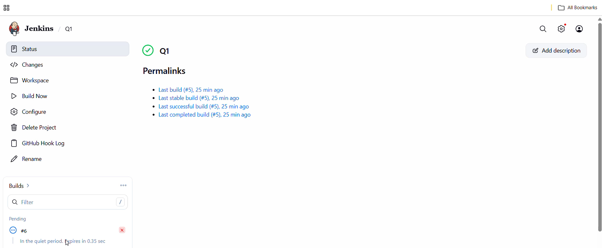

Job 2 auto build by webhook when changes made in repo 1 2026-Q2 branch
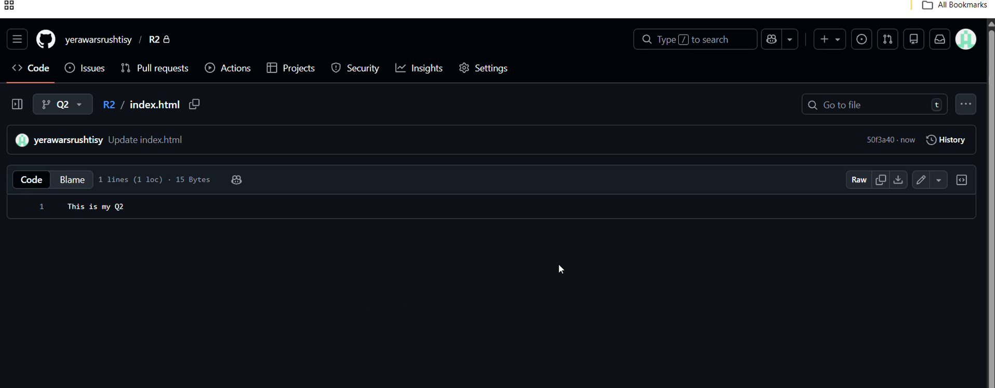
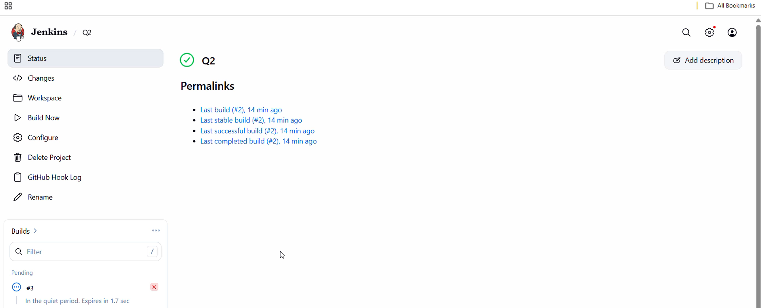

Job 3 auto build by webhook when changes made in repo 1 2026-Q3 branch

